ReactJS - The login page with react JavaScript

Element

 <Container component="main" maxWidth="xs">

          <TextField

          variant="outlined"

          margin="normal"

          fullWidth

          label="email"

          value={email}

          onChange={(e) => setEmail(e.target.value)}

          error={!!errors.email}

          helperText={errors.email}

        />

       </Container>

Use State

const [email, setEmail] = useState('');

const [password, setPassword] = useState('');

const [errors, setErrors] = useState({ email: '', password: '' });

Validations

const validateEmail = () => {

    // Basic email format validation

    const emailRegex = /^[^\s@]+@[^\s@]+\.[^\s@]+$/;

    return emailRegex.test(email);

  };

  const validatePassword = () => {

    // Basic password length validation

    return password.length >= 6 && password.length <= 15;

  };

Handle Login

 const handleLogin = () => {

    // Reset previous errors

    setErrors({ email: '', password: '' });

    // Validation

    if (!validateEmail()) {

      setErrors((prevErrors) => ({ ...prevErrors, email: 'Invalid email format' }));

      return;

    }

    if (!validatePassword()) {

      setErrors((prevErrors) => ({ ...prevErrors, password: 'Password must be at least 6 characters' }));

      return;

    }

    // Add your login logic here

    console.log('Logging in with:', email, password);

  };

Output

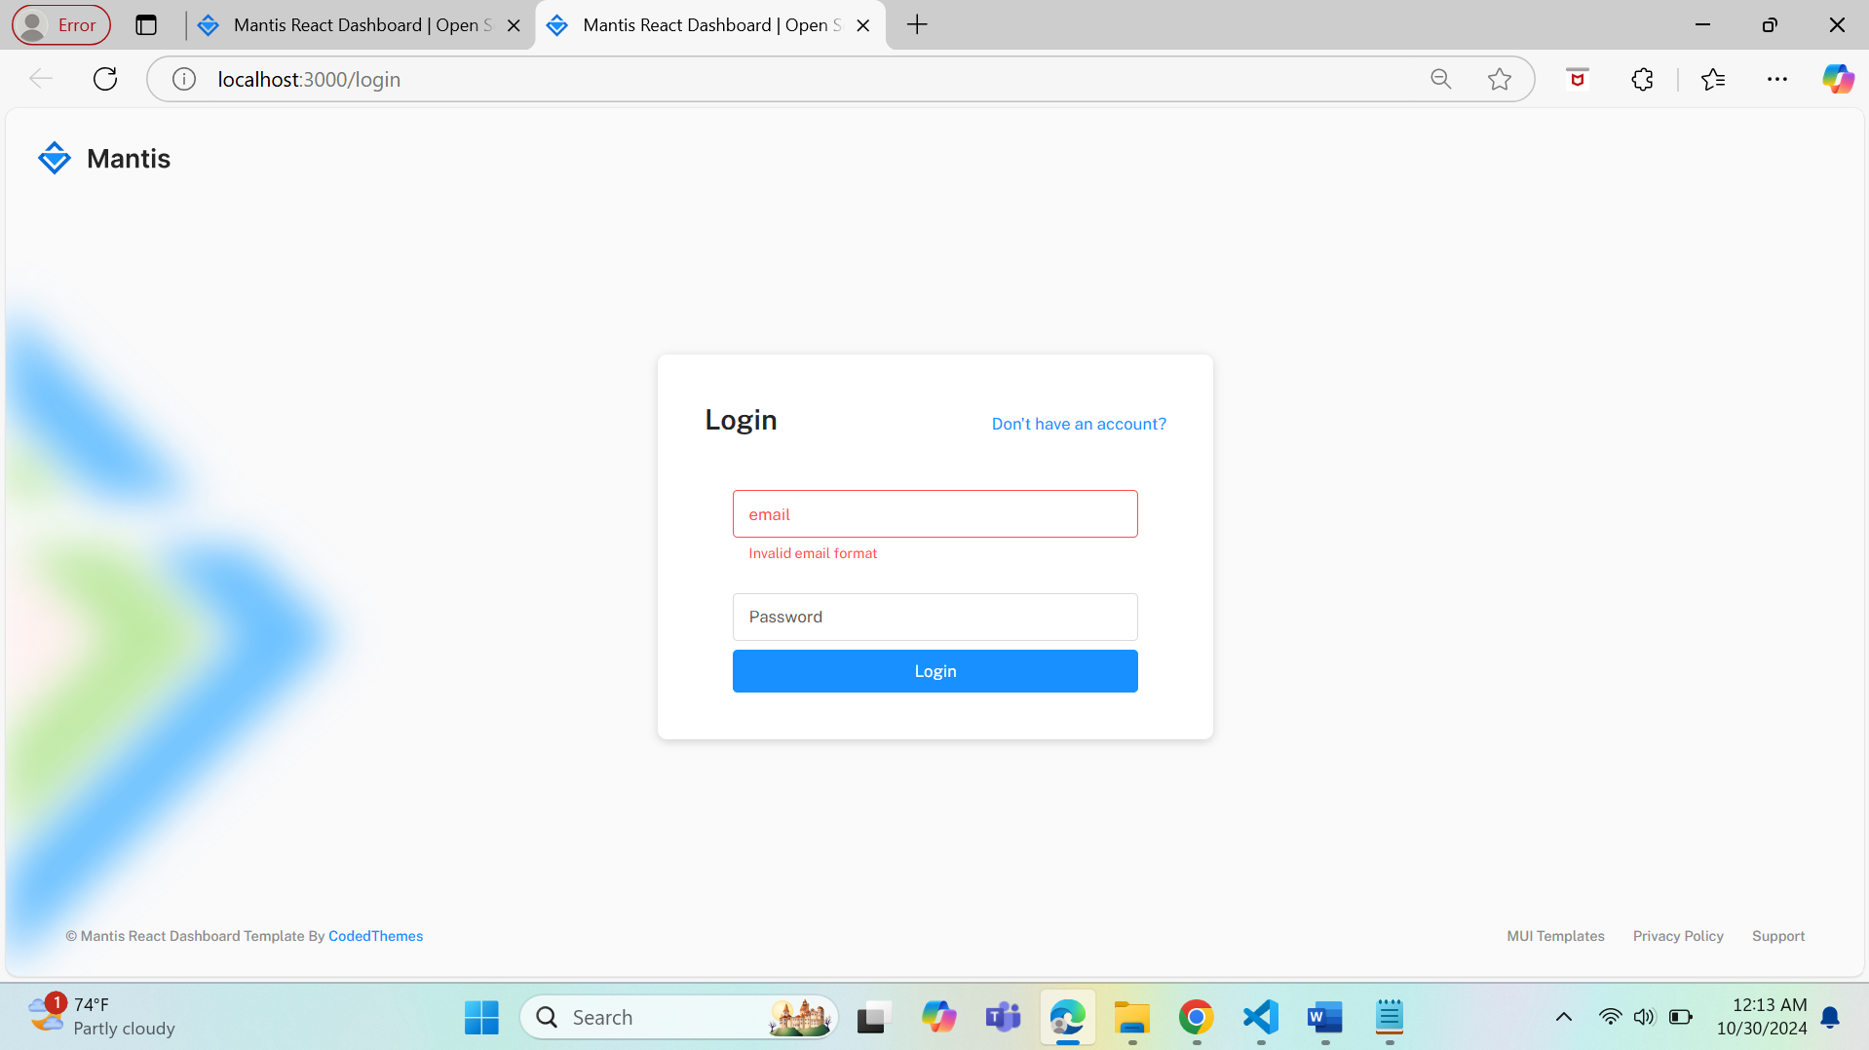

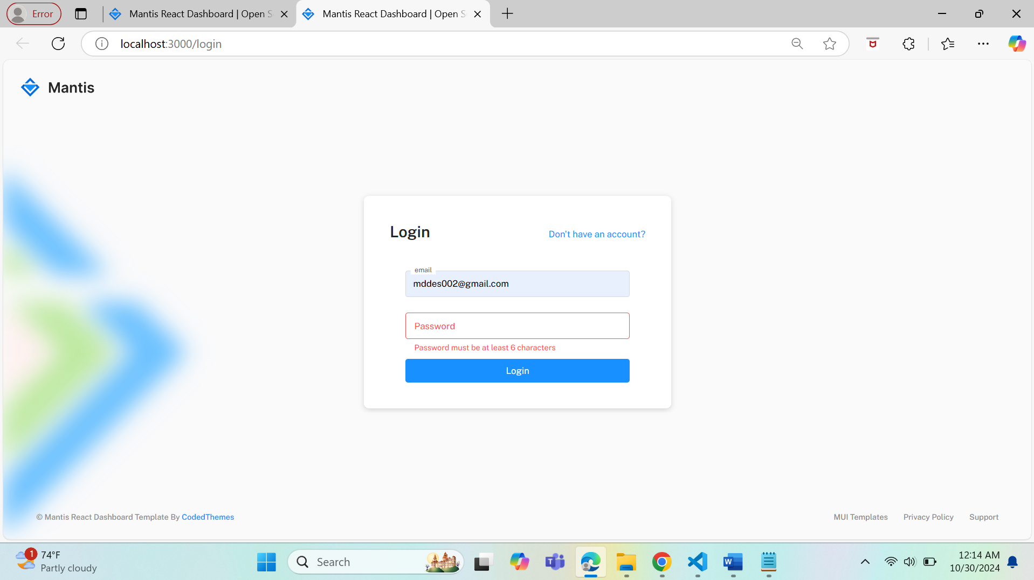

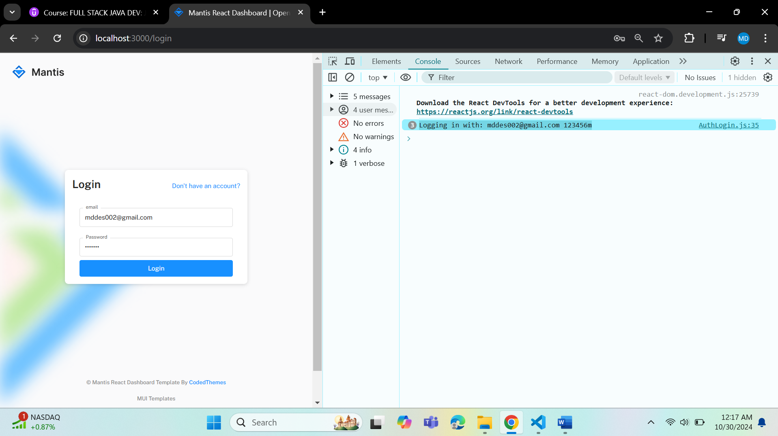

Final Source Code

import React,{useState} from 'react';

import { Button, TextField, Container } from '@mui/material';

const AuthLogin = () => {6

  const [email, setEmail] = useState('');

  const [password, setPassword] = useState('');

  const [errors, setErrors] = useState({ email: '', password: '' });

  const validateEmail = () => {

    // Basic email format validation

    const emailRegex = /^[^\s@]+@[^\s@]+\.[^\s@]+$/;

    return emailRegex.test(email);

  };

  const validatePassword = () => {

    // Basic password length validation

    return password.length >= 6 && password.length <= 15;

  };

  const handleLogin = () => {

    // Reset previous errors

    setErrors({ email: '', password: '' });

    // Validation

    if (!validateEmail()) {

      setErrors((prevErrors) => ({ ...prevErrors, email: 'Invalid email format' }));

      return;

    }

    if (!validatePassword()) {

      setErrors((prevErrors) => ({ ...prevErrors, password: 'Password must be at least 6 characters' }));

      return;

    }

    // Add your login logic here

    console.log('Logging in with:', email, password);

  };

    return (

      <Container component="main" maxWidth="xs">

          <TextField

          variant="outlined"

          margin="normal"

          fullWidth

          label="email"

          value={email}

          onChange={(e) => setEmail(e.target.value)}

          error={!!errors.email}

          helperText={errors.email}

        />

         <TextField

          variant="outlined"

          margin="normal"

          fullWidth

          label="Password"

          type="password"

          value={password}

          onChange={(e) => setPassword(e.target.value)}

          error={!!errors.password}

          helperText={errors.password}

        />

         <Button variant="contained" color="primary" fullWidth onClick={handleLogin}>

          Login

        </Button>

       </Container>

    )

};

export default AuthLogin;